Donkey Car (DPRG Version) Competition
(rule version 20191010.00)

Donkey Car: Donkey Car is an open-source DIY self-driving platform for small scale cars. This project is a starting point for many experimenters exploring neural networks. The project documentation can be found at donkeycar.com. There is also an active community of Donkey Car makers that can be found at https://www.donkeycar.com/community.html. The Donkey Car community holds many competitions and have their own set of rules. These community Donkey Car rules do not apply to the DPRG competition. The rules in this document are the only rules applicable for the DPRG competition. These rules are influenced by the inputs of DPRG members, DPRG’s meeting location limitations and contest time constraints.

Objective: The robot will start at a starting line on a course that resembles a “road”. The robot will transverse the course for a specific period of time. While following the course, the robot will strive to stay between the two tape defined edges of the course. The two tape edges are approximately 24 inches apart. The course will be a closed loop. Small orange cones will be placed at turns within the loop. The robot must follow the course. No penalty will be given for small deviations from the course; however, penalties will be added for hitting cones. Several conditions can terminate the robots run (see Run Definition). Each robot makes its run without other robots on the course. Time will be allotted before the contest for robots to train to the course, however this time will be very limited.

Robot: Competing robots must run autonomously but are not required to be self-contained. All sensors must be mounted on the robot. Robot length and width is limited to 18x18 inches and may not become larger than this size at any stage of the contest. Maximum robot weight is 30 pounds. Robots are not required to use the Donkey Car project software.

Self-Contained Definition: Self-contained means that all computing power used to run the robot is carried on the robot platform.

Robot Training: Each robot will be allowed to train on the course before the competition begins for at least 15 minutes. Contestants are responsible for knowing the times the course is open for training and being ready to train.

Run Definition: A run starts when the robot is placed at the starting line of the course, given a signal from the judge, and moves. If the robot fails to move at least 12 inches, the competitor can remove the robot and try again at the end of the round. If the robot doesn’t move when given this 2nd chance, its run is forfeited. The run ends whenever the robot completes the objectives for the run time limit, or malfunctions after moving 12 inches, or hits 3 cones, or cuts inside an internal cone, or leaves the course in such as matter that a return to the course is unlikely (based on Judges decision). Each robot is allowed 1 run per contest round.

Run Time Limit: The run time limit is 5 minutes.

Round Definition: A round consists of a single run by each competing robot. The competition consists of 3 rounds.

Case of Large Competitor Count: In the case where the number of competitors will cause the competition time to exceed the available time, the judges can reduce the number rounds to 2, and/or change the run time limit to either 3 or 4 minutes. It is preferable to only change the number of rounds.

Play: At the start of the competition, the robot is placed at the starting line. The robot may travel the course in either a clockwise or counterclockwise direction.

The run’s timer will start when the robot starts to move.

Only the robot making the run will be on the course during the run.

The robot must follow the course, staying between the 2 taped edges of the course. It may deviate slightly beyond the edges of the course but must travel along the course’s path.

If the robot strikes or disturbs any cone located along the course, it will incur a penalty per cone hit.

Beacons or other navigational aids either in or outside of the arena are not allowed.

Course: The arena consists of a path marked with two blue painter tape (~36 mm wide) edges that make up a “road”. The 2 edges are approximately 24 inches apart. A starting line is located on the path. The path/road forms a closed loop made up of straight and curved segments. There may be additional blue painter tape lines crossing the course since the course may overlay other contest arenas. Small fluorescent cones or cans (5 to 9 inches in height) will be placed on both sides of the path at major curves. Cone locations will be marked with a small piece of painter tape, so cones can be returned to position between runs. Cone placement locations are decided by the judges.

Example Course Layout:
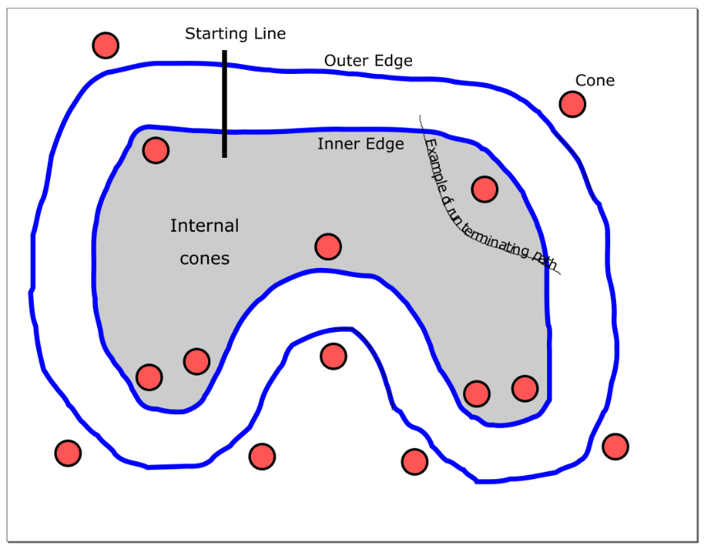
Image of a Sample Course:
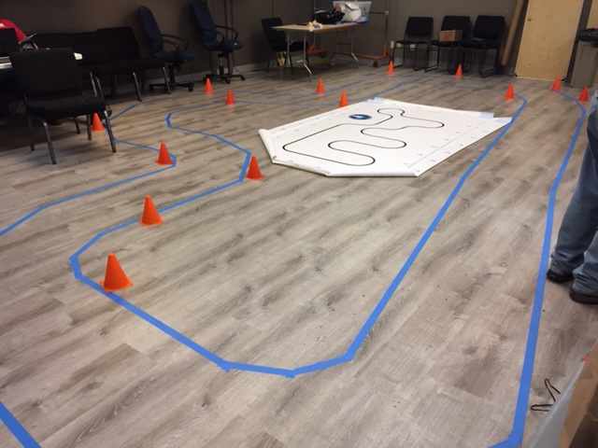

Scoring: A robot’s run score is the number of successful quarter lap segments (i.e., 0.25 of lap) that the robot travels within the run time limit or when the run is terminated, minus penalties.

A penalty of 1 quarter lap segment will be subtracted from the score of the robot for each cone either hit or disturbed.

The top three scores will be awarded 1st, 2nd, and 3rd place in the competition. If multiple robots tie for 1st place, they will each run one more time with their actual final distance marked with blue tape. The robot that finishes with the farthest distance wins the tie. The other initially tied robots will be awarded 2nd and 3rd place. Ties for non-1st place will be both awarded the place they are tied

No place or prize will be awarded to a robot that doesn’t at least have a score of 2 in a run during the competition (i.e., travel ½ lap around course without hitting any cones).

An example scoring: A robot travels the course for 2-2/3 laps before passing an internal cone on the wrong side and hitting one cone. The robot’s run score is 10 (# of quarter laps) – 1 (cones hit) = 9.

Safety: Robots that exhibit behavior or speed that is unsafe or may cause damage to the course’s location will be stopped from running by the judges.

Judging: One or more judges will referee the contest. They will ensure the rules are followed and remove a robot from competition if the robot is operating in an unsafe manner or not complying with the rules. The decisions of the judges are final.

